**Architecture of Lenet-5**

**Objective:**

* Transfer learning through Pre-trained models is a time and cost-efficient solution for deep learning problems.
* Understand the Architecture of Lenet-5 as proposed by the authors.

**Introduction:**

Transfer learning is the method that uses a neural network trained on a large and generalized enough dataset and being used for another problem. These neural networks are called Pre-trained networks.

The basic requirement for transfer learning is the availability of a pre-trained network. Luckily, we have several state of the art deep learning networks shared by the respective teams. Like for computer vision we have

* Lenet-5
* Alexnet
* VGG16
* inception-v3
* Restnet

## Lenet5:

* LeNet was introduced in the research paper “[Gradient-Based Learning Applied To Document Recognition](http://vision.stanford.edu/cs598_spring07/papers/Lecun98.pdf)” in the year 1998 by [Yann LeCun](http://yann.lecun.com/" \t "_blank), [Leon Bottou](https://leon.bottou.org/start), [Yoshua Bengio](https://yoshuabengio.org/" \t "_blank), and [Patrick Haffner](https://www.linkedin.com/in/patrick-haffner-bbb386/). Many of the listed authors of the paper have gone on to provide several significant academic contributions to the field of deep learning.They used this architecture for recognizing the handwritten and machine-printed characters.



[**Yann LeCun**](http://yann.lecun.com/)**,**[**Leon Bottou**](https://leon.bottou.org/start)**,**[**Patrick Haffner**](https://www.linkedin.com/in/patrick-haffner-bbb386/)**, and [Yoshua Bengio](https://yoshuabengio.org/" \t "_blank)**

**Advantage :**

* its simple and straightforward architecture.
* It is a multi-layer convolution neural network for image classification

## The Architecture of Lenet-5

* The network has 5 layers with learnable parameters and hence named Lenet-5. It has three sets of convolution layers with a combination of average pooling.
* After the convolution and average pooling layers, it has two fully connected layers. At last, a Softmax classifier which classifies the images into respective class.

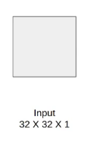

The input to this model is a 32 X 32 grayscale image hence the number of channels is one.

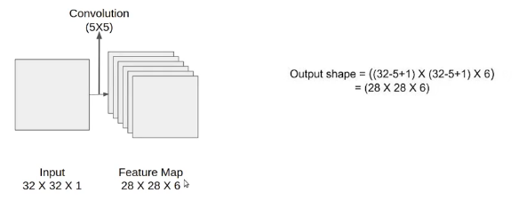

We then apply the first convolution operation with the filter size 5X5 and we have 6 such filters. As a result, we get a feature map of size 28X28X6. Here the number of channels is equal to the number of filters applied.

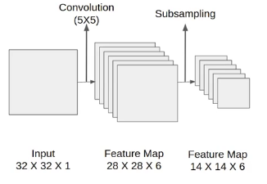

After CONV1(1 =first CONV layer), we apply the average pooling and the size of the feature map is reduced by half. Note that, the number of channels is intact.

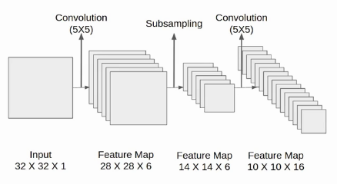

Next, we have a convolution layer(CONV2) with sixteen filters of size 5X5. Again the feature map changed it is 10X10X16. The output size is calculated in a similar manner. After this, we again applied an average pooling or subsampling layer, which again reduce the size of the feature map by half i.e 5X5X16.

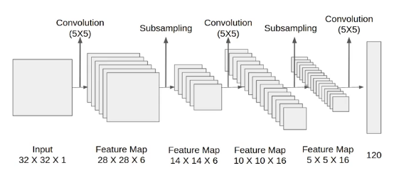

Then we have a final convolution layer of size 5X5 with 120 filters. As shown in the above image. Leaving the feature map size 1X1X120. After which flatten result is 120 values.

After these convolution layers, we have a fully connected layer with eighty-four neurons. At last, we have an output layer with ten neurons since the data have ten classes.

Here is the final architecture of the Lenet-5 model.

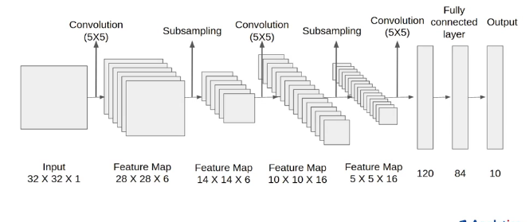

## Architecture Details

Let’s understand the architecture in more detail.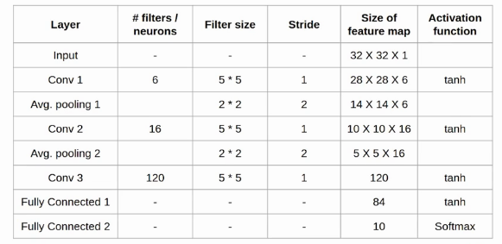

The first layer is the input layer with feature map size 32X32X1.

Then we have the first convolution layer with 6 filters of size 5X5 and stride is 1. The activation function used at his layer is tanh. The output feature map is  28X28X6.

Next, we have an average pooling layer with filter size 2X2 and stride 1. The resulting feature map is 14X14X6. Since the pooling layer doesn’t affect the number of channels.

After this comes the second convolution layer with 16 filters of 5X5 and stride 1. Also, the activation function is tanh. Now the output size is 10X10X16.

Again comes the other average pooling layer of 2X2 with stride 2. As a result, the size of the feature map reduced to 5X5X16.

The final pooling layer has 120 filters of 5X5  with stride 1 and activation function tanh. Now the output size is 120.

The next is a fully connected layer with 84 neurons that result in the output to 84 values and the activation function used here is again tanh.

The last layer is the output layer with 10 neurons and  Softmax function. The Softmax gives the probability that a data point belongs to a particular class. The highest value is then predicted.

This is the entire architecture of the Lenet-5 model. The number of trainable parameters of this architecture is around sixty thousand.

The network has

* 5 layers with learnable parameters.
* The input to the model is a grayscale image.
* It has 3 convolution layers, two average pooling layers, and two fully connected layers with a softmax classifier.
* The number of trainable parameters is 60000.